Monches Fish and Game
< VEST’s >
Apparel Options

Ordering Tips:
- Print copy of order form under Merchandise Tab or Record your items on a piece of paper, then fill in form and submit.
- Choose Item #.
- Choose Color.
- Choose Letter Colors. Refer to options shown below Item #.

All orders must include,
- Item #.
- Color. May only come in one pattern. See description or pictures for options
- Letter Color. Unless indicated, Letters may only come in one color.

- Use electronic order form under Merchandise Tab to place orders.
- Either preprint it & use as worksheet or write down items on piece of paper, then enter onto electronic form.
- Once form is completed, choose submit. Order will be sent to Bob Lunowa for processing. A confirmation notice will be sent to you verifying receipt of your order.

Sample Order Information:
Item # J709
Item Price $10.00.
Item Color: Olive Green
Item Letter Colors: Orange
Qty: 2
Total Order Cost: $40.00
Name: Harry Hatter
Address: 123 Order Street, Hartland WI, 53029
Phone: 414 123 – 4567
Email: xxxxxxxxxxxx@yahoo.com

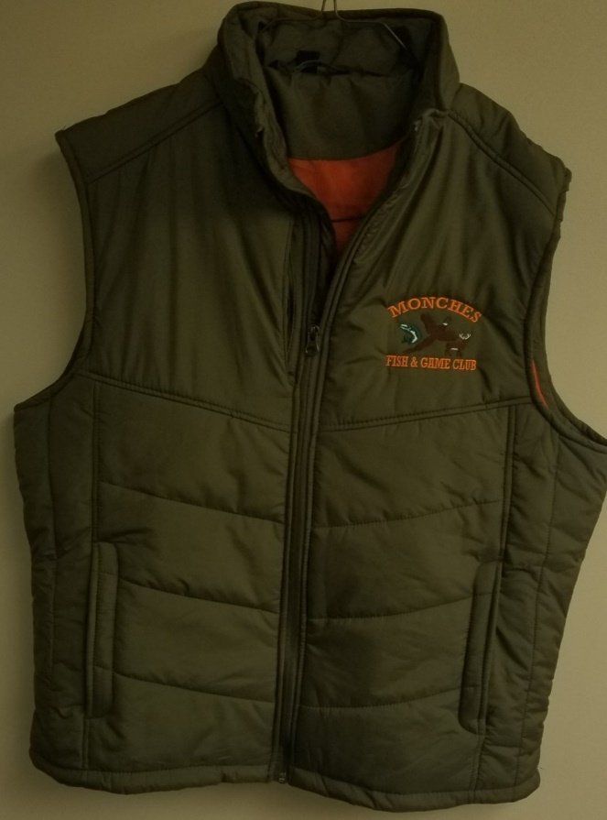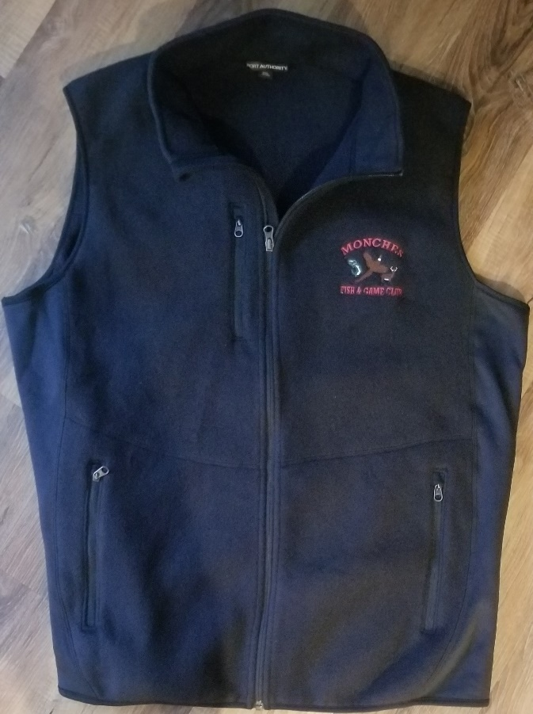
Item # J709 Puffy Vest Item # F228 Vest with Chest Pocket
Material: 100% Poly Shell - Front Pockets Material: 12oz 100% Polyester
Color Options: Olive Green / Black / Blue Color Options: (Black / Navy / Charcoal
Letter Color: Orange / Black / Red / White Letter Color Options: Black / Orange / White / Red
Price: S – XL $47.99 Price S – XL $43.99
Price: 2XL – 4XL $53.99 Price: 2XL – 4XL $47.99

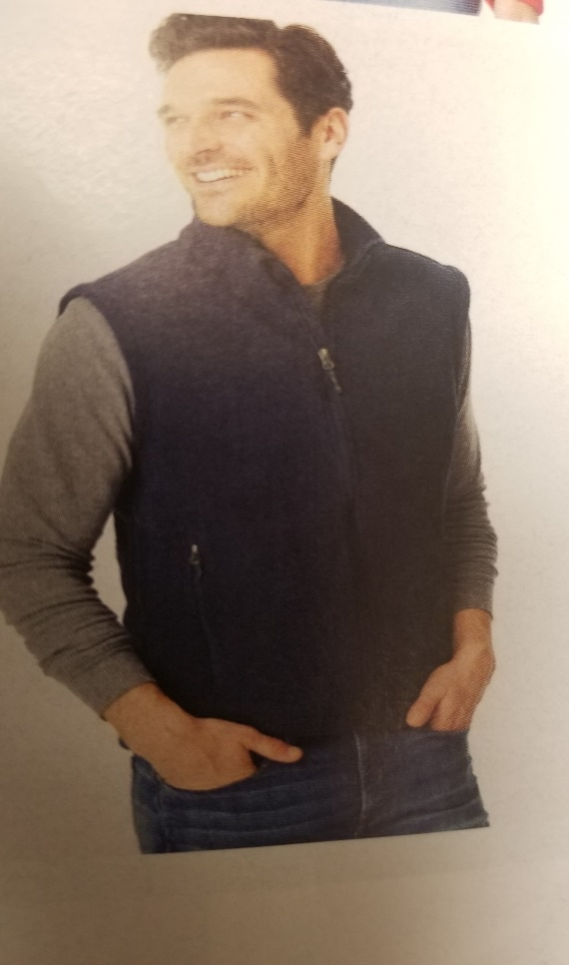

Item # F219 Value Fleece Vest
Material: 13.8 Oz 100% Polyester Front Pockets
Color Options: ( Black / Navy / Gray / Red / For Green / Royal )
Letter Color Options: Black / Red / White / Orange
Price: S – XL $31.99
Price: 2XL – 4XL $34.99

