Monches Fish and Game
< Sweatshirts & Pullovers >
Apparel Options

Ordering Tips:
- Print copy of order form under Merchandise Tab or Record your items on a piece of paper, then fill in form and submit.
- Choose Item #.
- Choose Color.
- Choose Letter Colors. Refer to options shown below Item #.

All orders must include,
- Item #.
- Color. May only come in one pattern. See description or pictures for options
- Letter Color. Unless indicated, Letters may only come in one color.

- Use electronic order form under Merchandise Tab to place orders.
- Either preprint it & use as worksheet or write down items on piece of paper, then enter onto electronic form.
- Once form is completed, choose submit. Order will be sent to Bob Lunowa for processing. A confirmation notice will be sent to you verifying receipt of your order.

Sample Order Information:
Item # ST266
Item Price $40.00.
Item Color: Black
Item Letter Colors: Orange
Qty: 2
Total Order Cost: $40.00
Name: Harry Hatter
Address: 123 Order Street, Hartland WI, 53029
Phone: 414 123 – 4567
Email: xxxxxxxxxxxx@yahoo.com

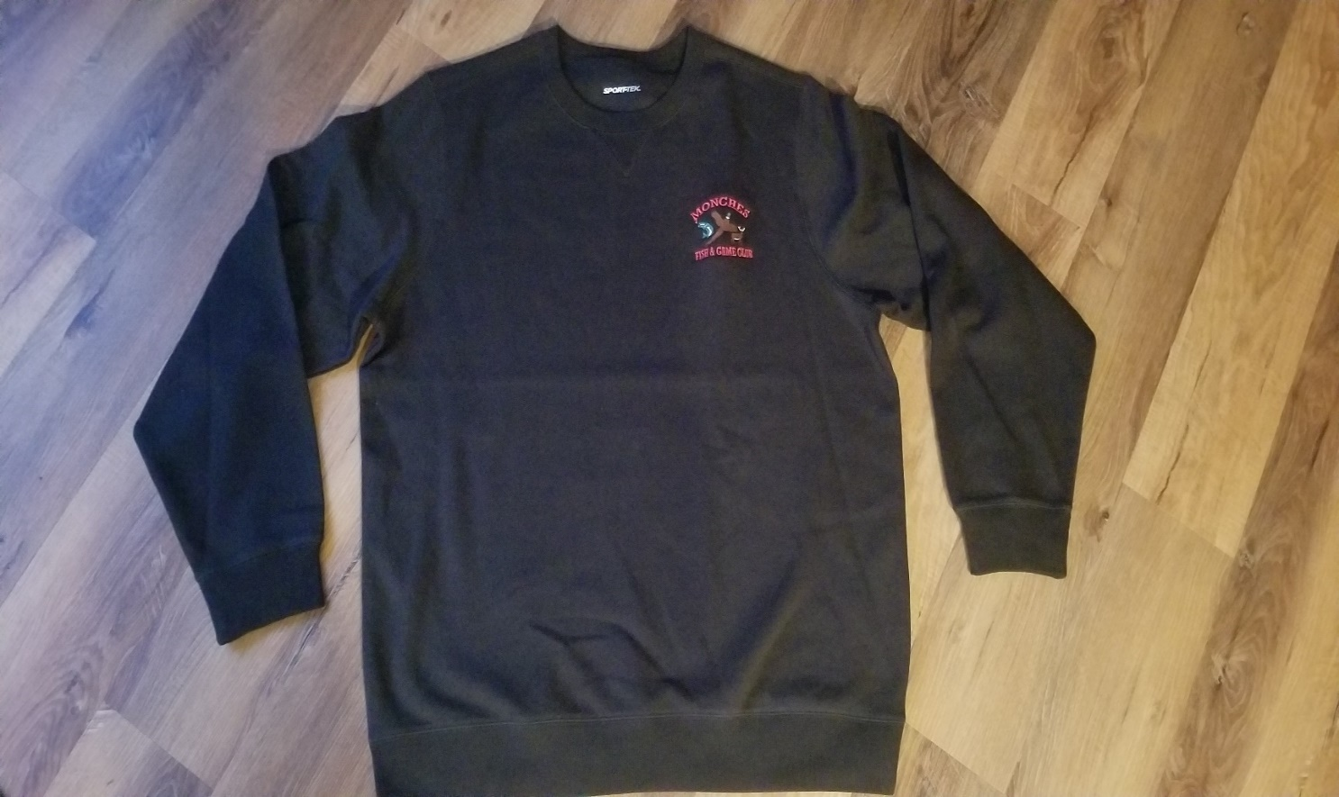

Item # ST266 Sport Tek Crew Sweatshirt
Material: 65 / 35 Cotton / Polyester Blend
Color Options: ( Black / Navy )
Letter Color Options: Red / White / Orange
Price: SM – XL $36.99
Price: 2XL – 4XL $39.99

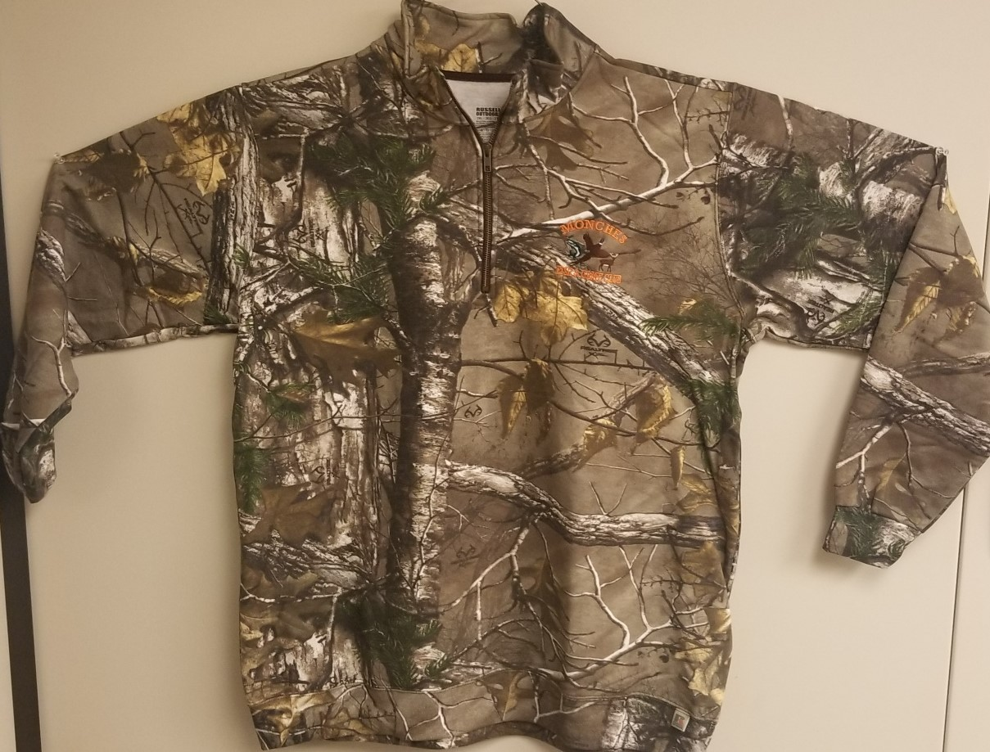

Item # RO78Q Russel (¼ Zip) Sweatshirt
Material: 8oz, 50 / 50 Cotton / Polyester
Color Options: Camo RealTree
Letter Color: Black / Red / White / Orange
Price: SM – XL $46.99
Price: 2XL – 4XL $49.99

Item # RO78ZH Russel (Full Zip) Sweatshirt
Material: 8oz, 50 / 50 Cotton / Polyester
Color Options: Camo RealTree
Letter Color: Black / Red / White / Orange
Price: SM – XL $56.99
Price: 2XL – 4XL $59.99

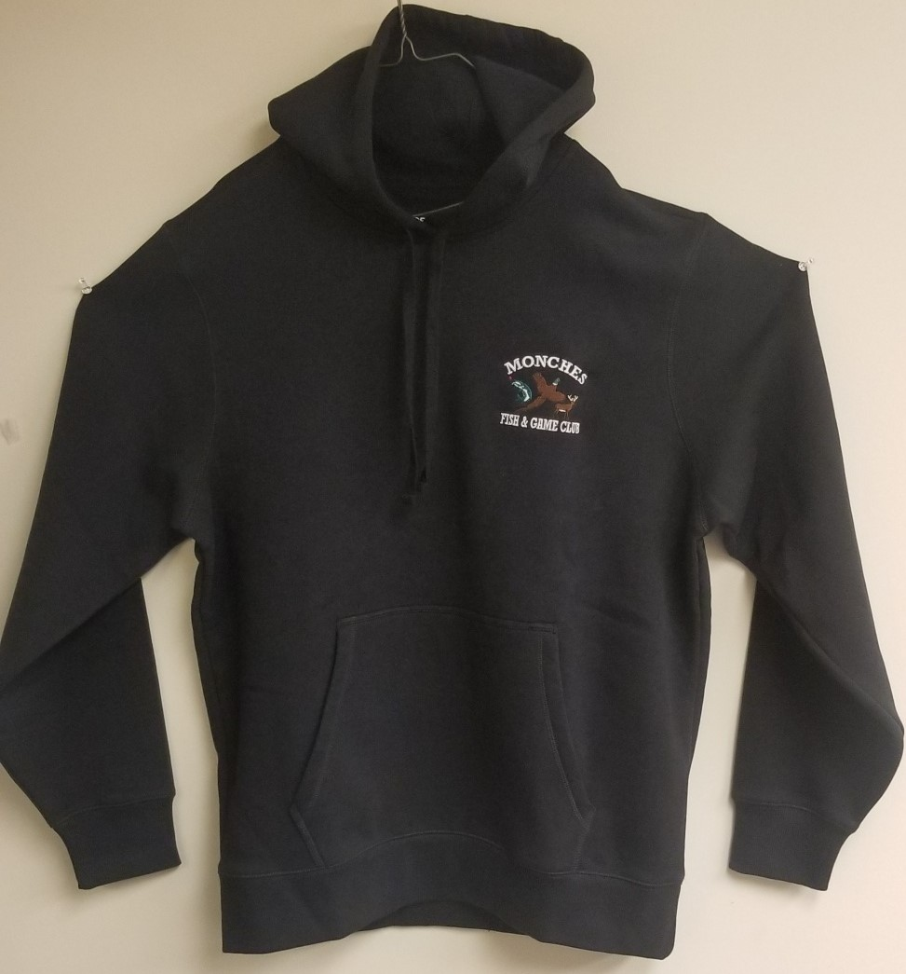

Item # ST254 Sport Tek Hoodie
Material: 9 oz 65 / 35 Cotton / Polyester
Color Options: ( Black / Navy / Forrest Green / Maroon / Red )
Letter Color Options: Black / Red / White / Orange
Price: SM – XL $35.99
Price: 2XL – 4XL $37.99

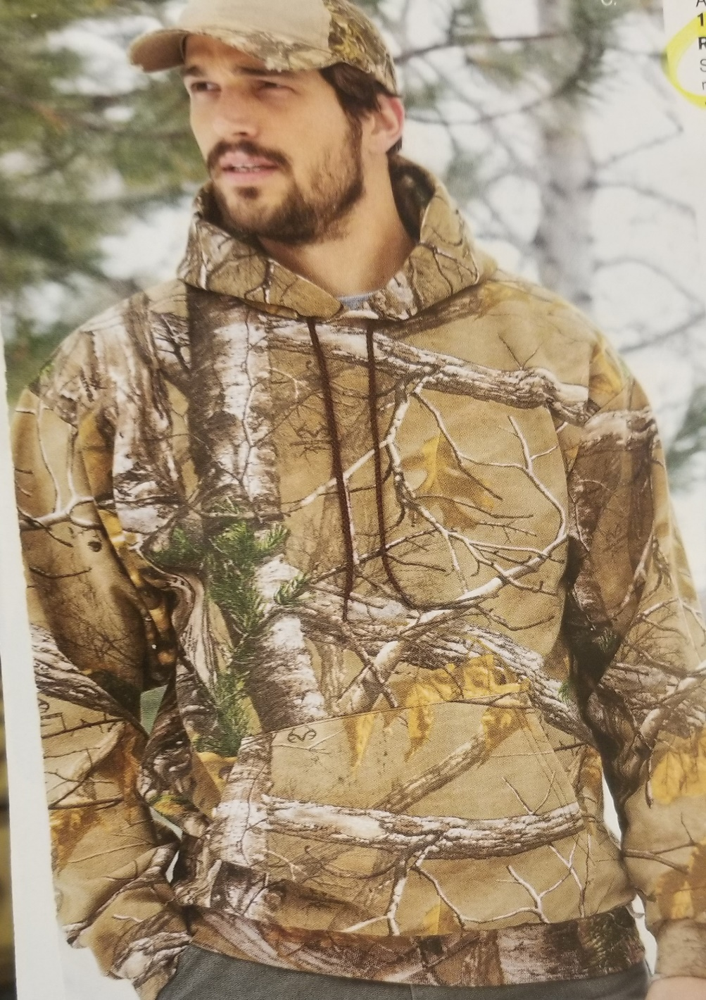

Item # S459R Russell RealTree Hoodie
Material: 8 oz 50 / 50 Cotton / Polyester
Color Options: ( RealTree Camo )
Letter Color Options: Black / Red / White / Orange
Price: SM – XL $49.99
Price: 2XL – 4XL $51.99

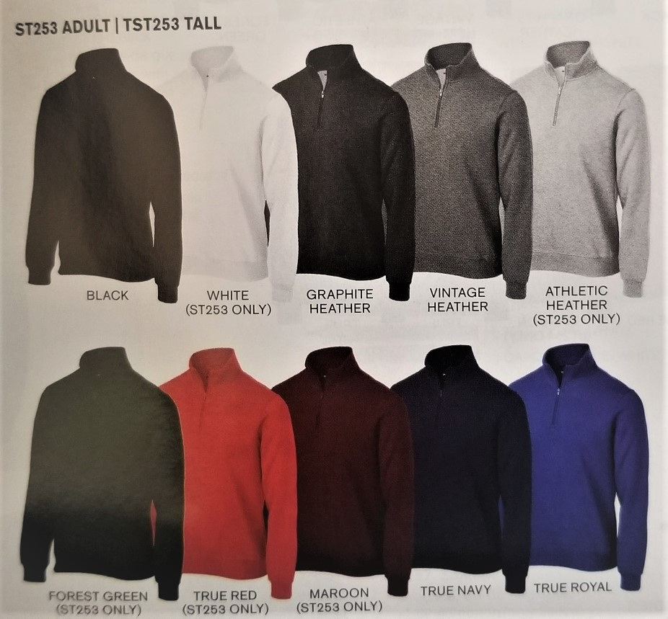

Item # ST253 Sport Tek ¼ Zip (Solid) Pullover
Material: 9 oz 65 / 35 Cotton / Polyester
Color Options: ( See Above )
Letter Color Options: Black / Red / White / Orange
Price: SM – XL $36.99
2XL – 4XL $39.99

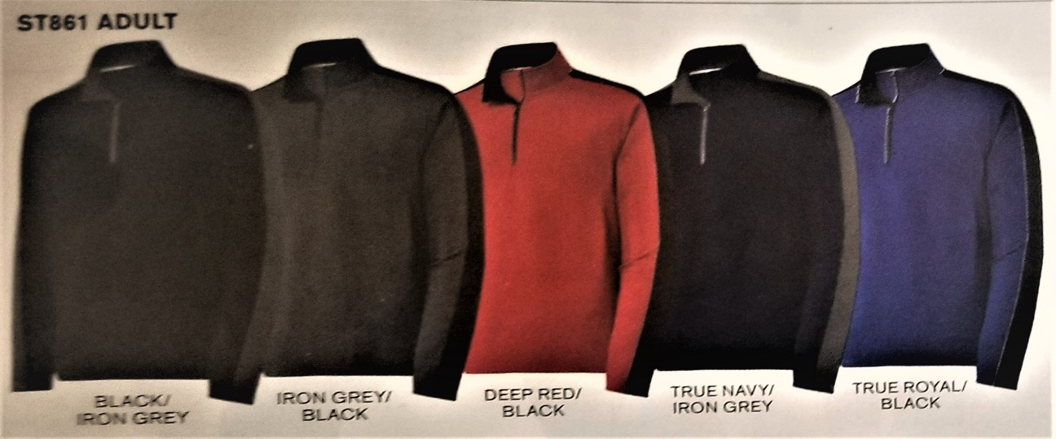

Item # ST861 Sport Tek - Sport Wick (¼ Zip) Color Block (Two Tone) Pullover
Material: 9 oz 100% Polyester
Color Options: ( See Above )
Letter Color Options: Black / Red / White / Orange
Price: SM – XL $38.99
2XL – 4XL $42.99

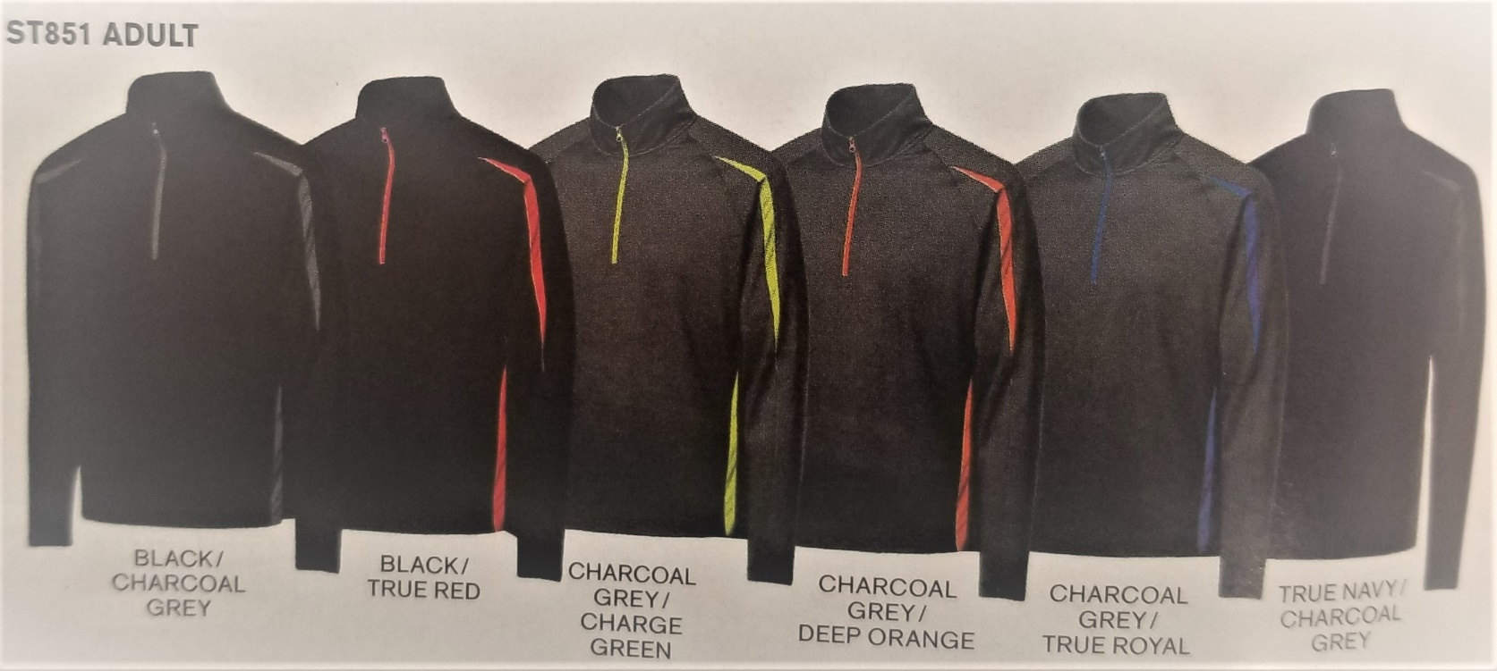

Item # ST851 Sport Tek - Sport Wick (1/2 Zip) Color Block (Stretch) Pullover
Material: 90 / 10 Poly / Spandex
Color Options: ( See Above )
Letter Color Options: Black / Red / White / Orange / Royal / Charge Green
Price: SM – XL $47.99
2XL – 4XL $52.99

