Monches Fish and Game
< Hat’s >
Apparel Options

Ordering Tips:
- Print copy of order form under Merchandise Tab or Record your items on a piece of paper, then fill in form and submit.
- Choose Hat Item #.
- Choose Hat Pattern . May only come in one pattern. If multiple, refer to pictures for color
Pattern descriptions.
- Choose Letter Colors. May only come in one color. Refer to options shown below Item # for options available.

All orders must include,
- Item #.
- Hat Color Pattern. May only come in one pattern. See description or pictures for options
- Hat Letter Color. Unless indicated, Letters may only come in one color. Ex, C804

- Use electronic order form under Merchandise Tab to place orders.
- Either preprint it & use as worksheet or write down items on piece of paper, then enter onto electronic form.
- Once form is completed, choose submit. Order will be sent to Bob Lunowa for processing. A confirmation notice will be sent to you verifying receipt of your order.

Sample Order Information:
Item # C804
Item Price $10.00.
Item Hat Pattern: Orange & RealTree
Item Letter Colors: Black
Qty: 2
Total Order Cost: $20.00
Name: Harry Hatter
Address: 123 Order Street, Hartland WI, 53029
Phone: 414 123 – 4567
Email: xxxxxxxxxxxx@yahoo.com

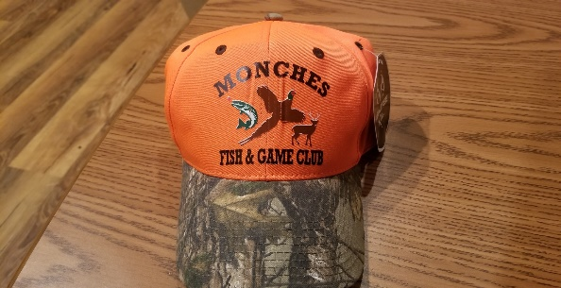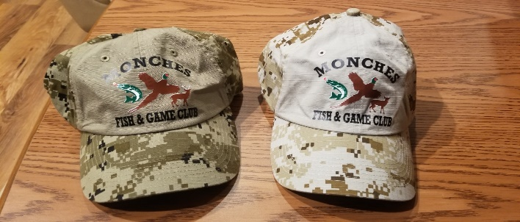
Item # C804 Item # C926
Pattern: Orange / RealTree Camo Pattern Options: (Green Camo) or (Sand Camo / Sand)
Letter Color: Black Letter Color Options: Black / Orange / White / Red
Price: $19.00 Price $19.00

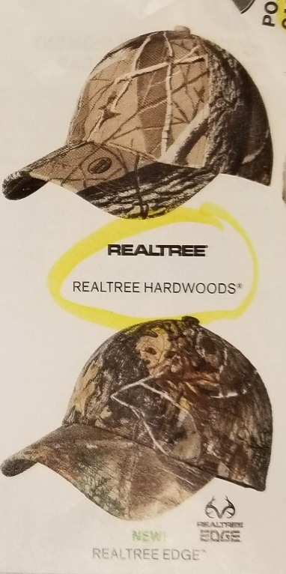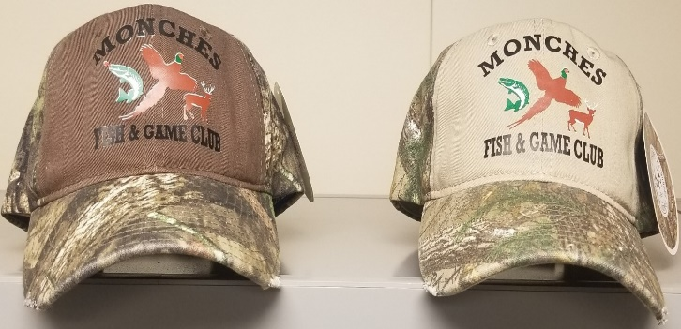
Item # C871 Item # C807
Pattern Options:(Realtree Hardwood) or (Realtree Edge) Patterns: (Moss Oak / Break Up) or (R-Tree / X Khaki)
Letter Color Options: Black / Red / White / Orange Letter Color Options: Black / Red / Orange / White
Price: $21.00 Price: $19.00

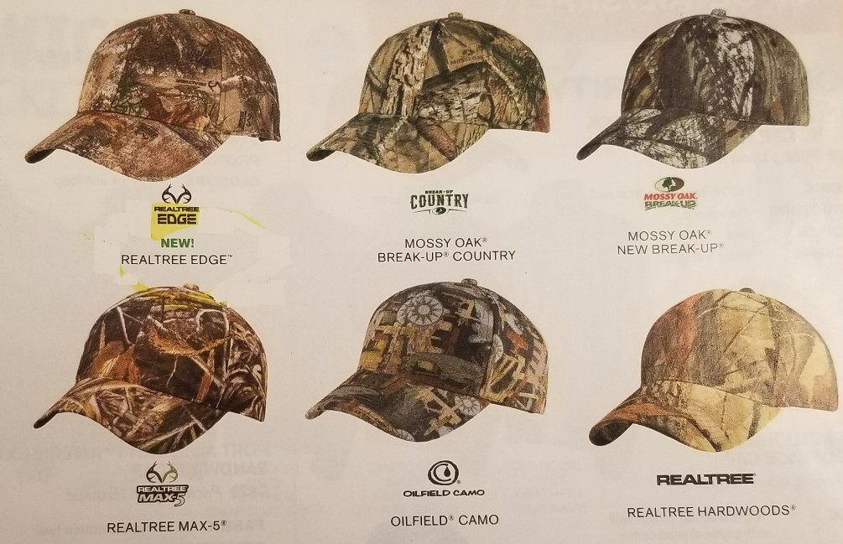

Item # C855
Pattern Options: (RealTree / Edge) (Mossy Oak / Breakup Country) (RealTree / Hardwoods)
Letter Color Options: Black / Red / Orange / White
Price: $21.00

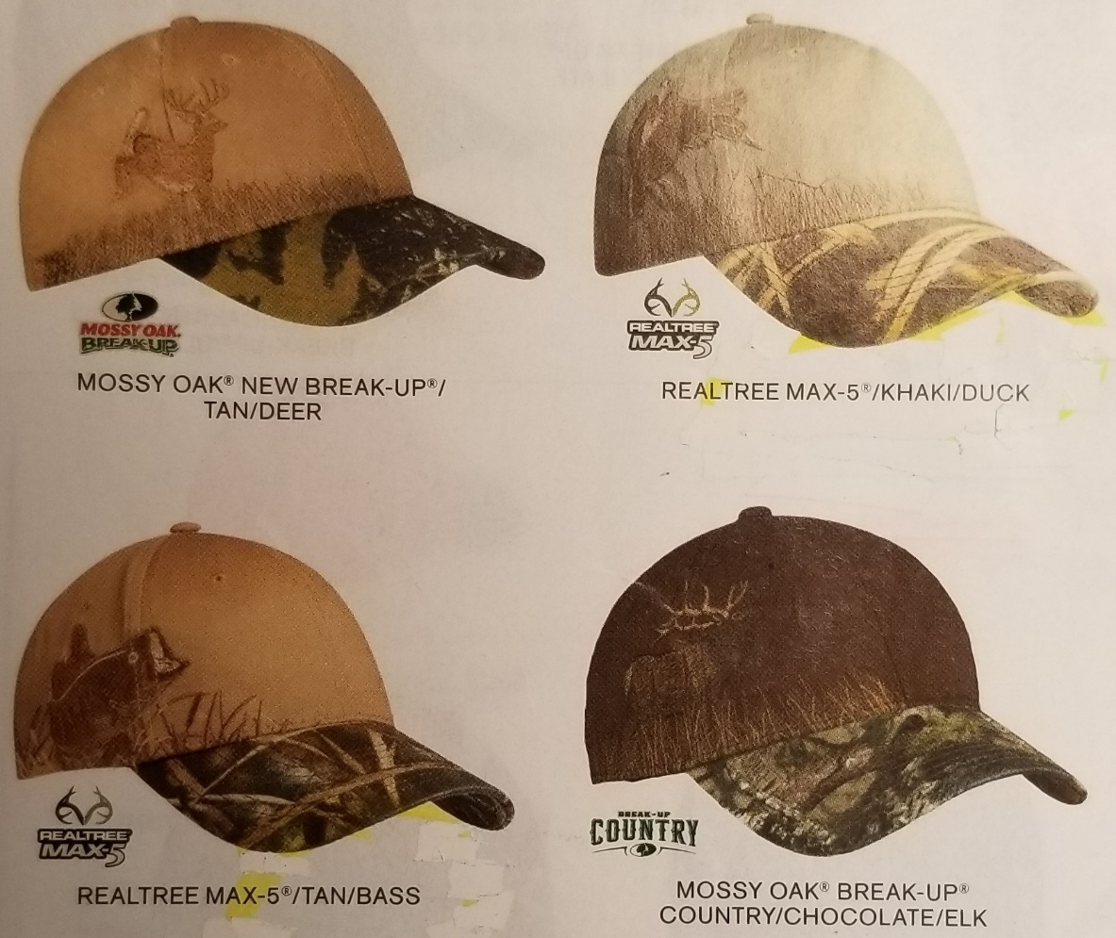

Item # C820
Pattern Options: Deer / Duck / Bass / Elk
Letter Color Options: Black / Red / White / Orange
Price: $25.00

