Monches Fish and Game
< Polo Shirts >
Apparel Options

Ordering Tips:
- Print copy of order form under Merchandise Tab or Record your items on a piece of paper, then fill in form and submit.
- Choose Item #.
- Choose Color.
- Choose Letter Colors. Refer to options shown below Item #.

All orders must include,
- Item #.
- Color. May only come in one pattern. See description or pictures for options
- Letter Color. Unless indicated, Letters may only come in one color.

- Use electronic order form under Merchandise Tab to place orders.
- Either preprint it & use as worksheet or write down items on piece of paper, then enter onto electronic form.
- Once form is completed, choose submit. Order will be sent to Bob Lunowa for processing. A confirmation notice will be sent to you verifying receipt of your order.

Sample Order Information:
Item # ST266
Item Price $40.00.
Item Color: Black
Item Letter Colors: Orange
Qty: 2
Total Order Cost: $40.00
Name: Harry Hatter
Address: 123 Order Street, Hartland WI, 53029
Phone: 414 123 – 4567
Email: xxxxxxxxxxxx@yahoo.com

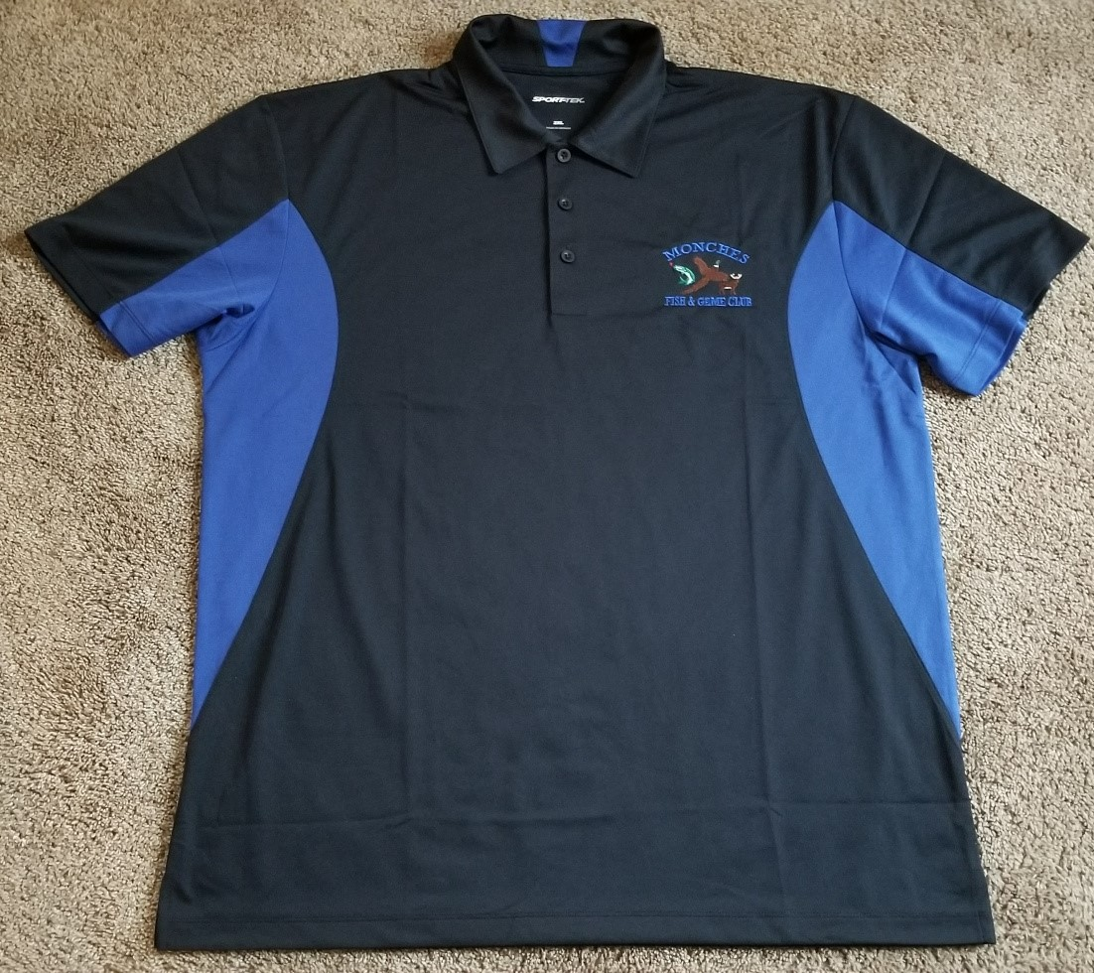

Item # ST655 Sport Tek – (Side Blocked) - Polo Shirt
Material: 3.8 oz 100% Polyester
Color Option: ( Black & Royal )
Letter Color Option: Royal Blue
Price: SM – XL $29.99
Price: 2XL – 6XL $31.99

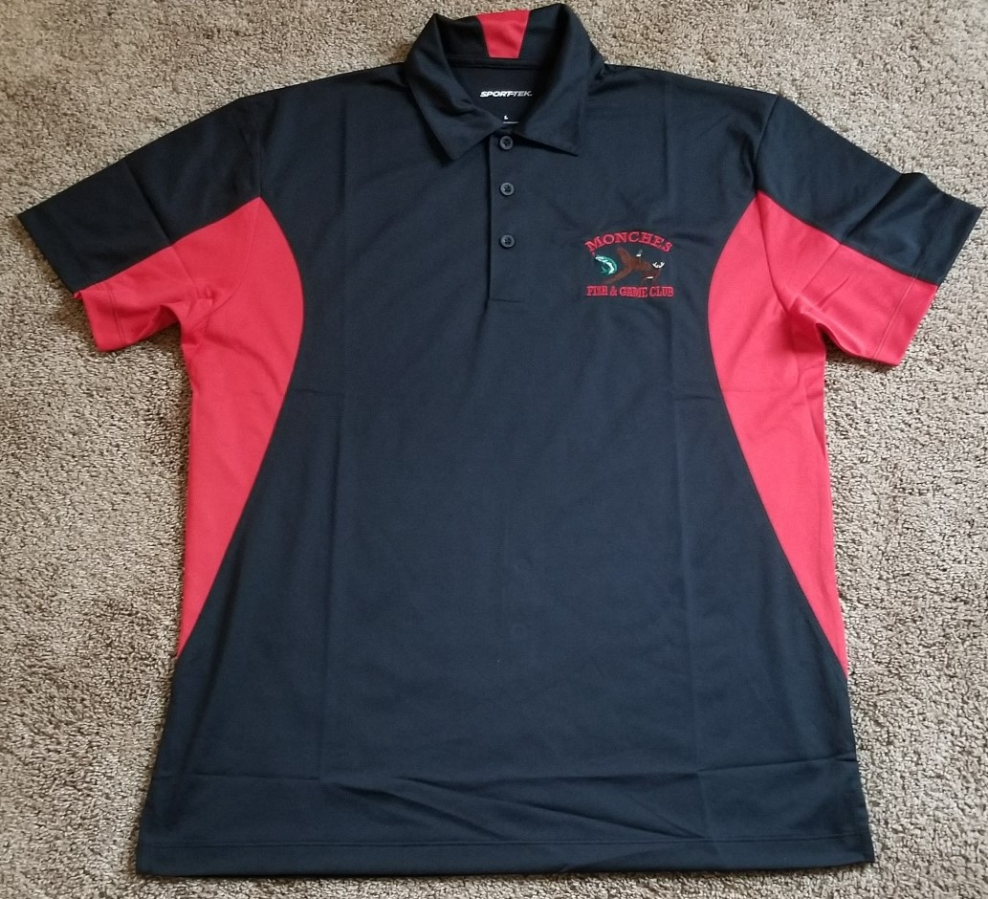

Item # ST655 Sport Tek – (Side Blocked) - Polo Shirt
Material: 3.8 oz 100% Polyester
Color Option: Black & Red
Letter Color: Red
Price: SM – XL $29.99
Price: 2XL – 6XL $31.99

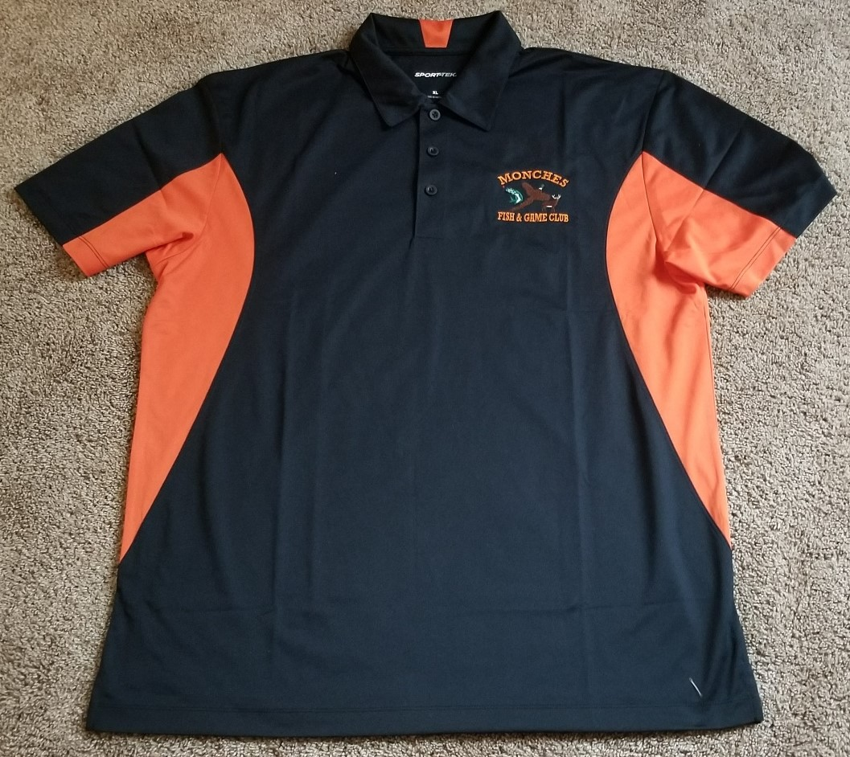

Item # ST655 Sport Tek – (Side Blocked) - Polo Shirt
Material: 3.8oz 100% Polyester
Color Options: Black & Orange
Letter Color: Orange
Price: SM – XL $29.99
Price: 2XL – 6XL $31.99

Sport Tek (K469) Polo - Color Pallett Options

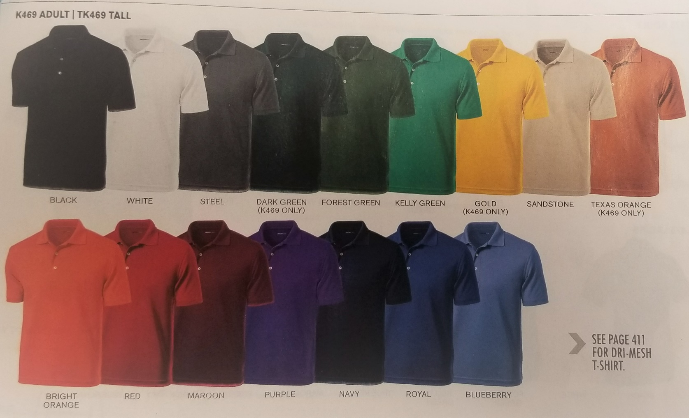

Item # K469 Sport Tek ( Dri – Mesh ) Polo Shirt
Material: 3.8 oz 100% Polyester
Color Options: ( See Above )
Letter Color Options: Black / Red / White / Orange
Price: SM – XL $29.99
2XL – 4XL $31.99

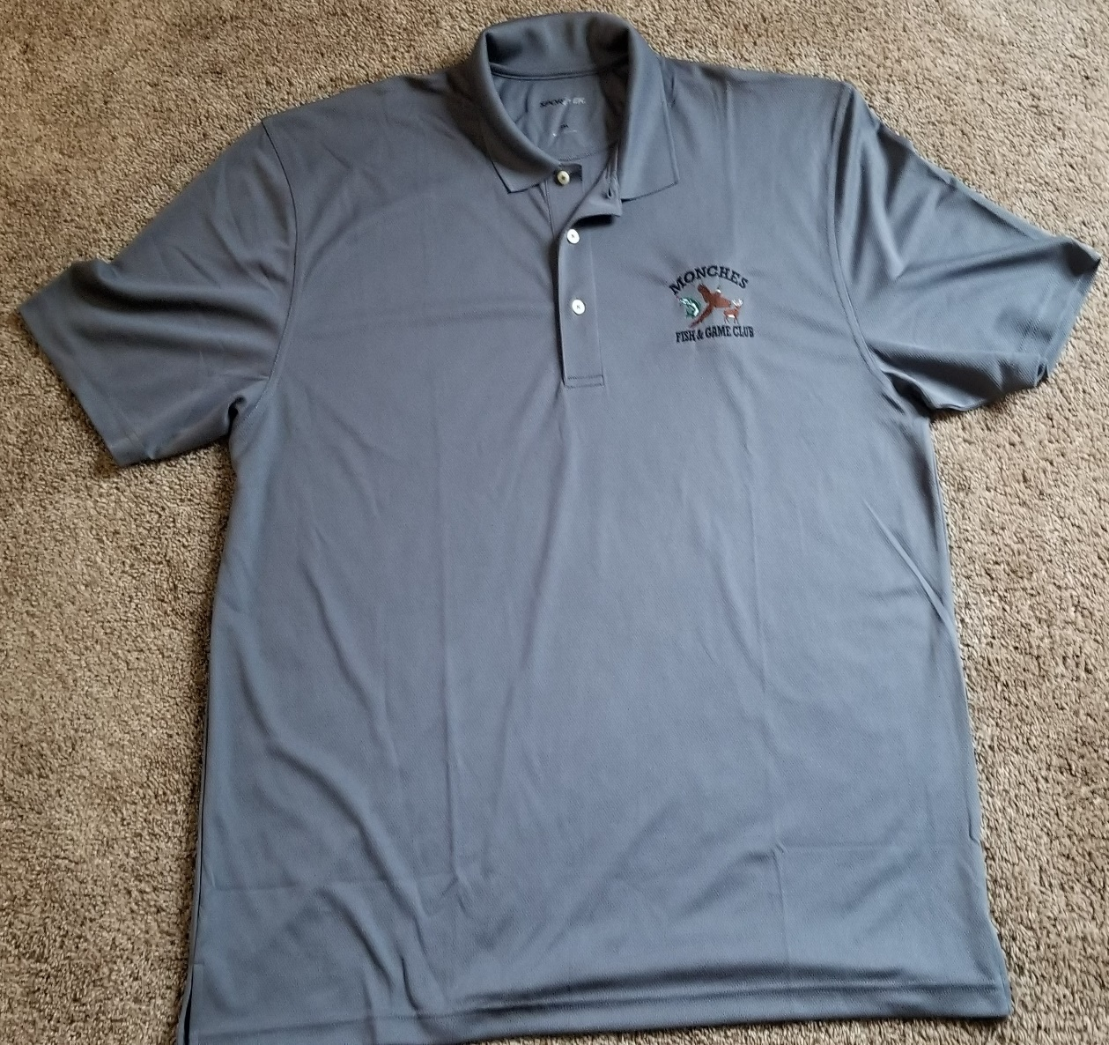

Item # K469 Sport Tek ( Dri – Mesh) Polo Shirt
Material: 3.8 oz 100% Polyester
Color Options: ( Black / White ) ( Navy / White) (Royal / White) (Blueberry / Navy)
(Steel / Black) - Shown in Picture
Letter Color Options: Black / Red / White / Orange
Price: SM – XL $29.99
2XL – 4XL $31.99

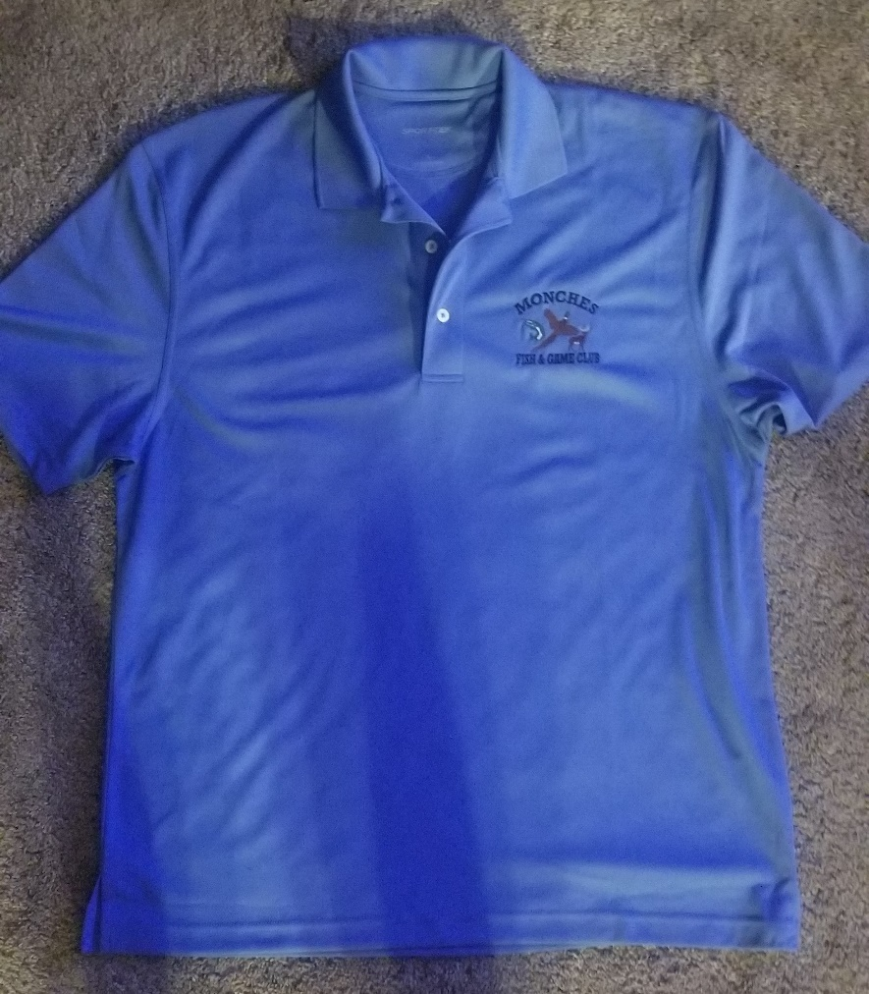

Item # K469 Sport Tek ( Dri - Mesh ) Polo Shirt
Material: 3.8 oz 100% Polyester
Color Options: ( Black / White ) ( Navy / White) (Steel / Black) (Royal / White)
(Blueberry / Navy) - Shown in Picture
Letter Color Options: Black / Red / White / Orange
Price: SM – XL $29.99
2XL – 4XL $31.99

