Monches Fish and Game
< Jackets >
Apparel Options

Ordering Tips:
- Print copy of order form under Merchandise Tab or Record your items on a piece of paper, then fill in form and submit.
- Choose Item #.
- Choose Color.
- Choose Letter Colors. Refer to options shown below Item #.

All orders must include,
- Item #.
- Color. May only come in one pattern. See description or pictures for options
- Letter Color. Unless indicated, Letters may only come in one color.

- Use electronic order form under Merchandise Tab to place orders.
- Either preprint it & use as worksheet or write down items on piece of paper, then enter onto electronic form.
- Once form is completed, choose submit. Order will be sent to Bob Lunowa for processing. A confirmation notice will be sent to you verifying receipt of your order.

Sample Order Information:
Item # F230C
Item Price $40.00.
Item Color: Black / Camo
Item Letter Colors: Orange
Qty: 2
Total Order Cost: $40.00
Name: Harry Hatter
Address: 123 Order Street, Hartland WI, 53029
Phone: 414 123 – 4567
Email: xxxxxxxxxxxx@yahoo.com

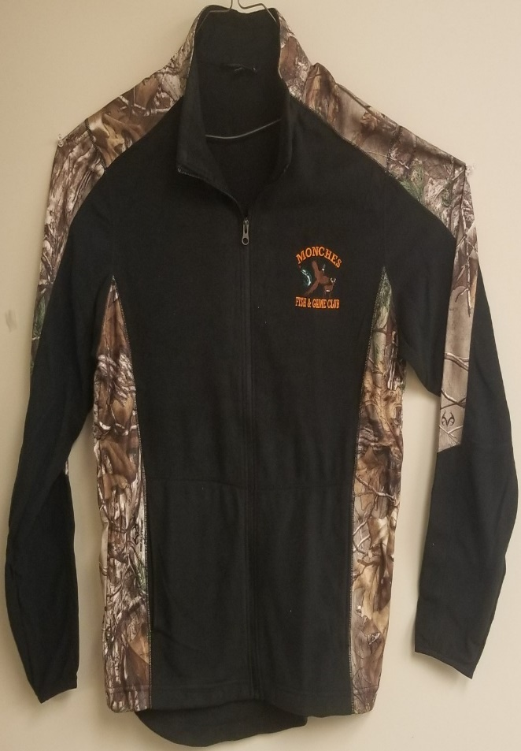

Item # F230C Port Authority Microfleece Full Zip Jacket
Material: 100% Polyester Front Pockets
Color Options: ( Black / Camo )
Letter Color Options: Red / White / Orange
Price: SM – XL $43.99
Price: 2XL – 4XL $47.99

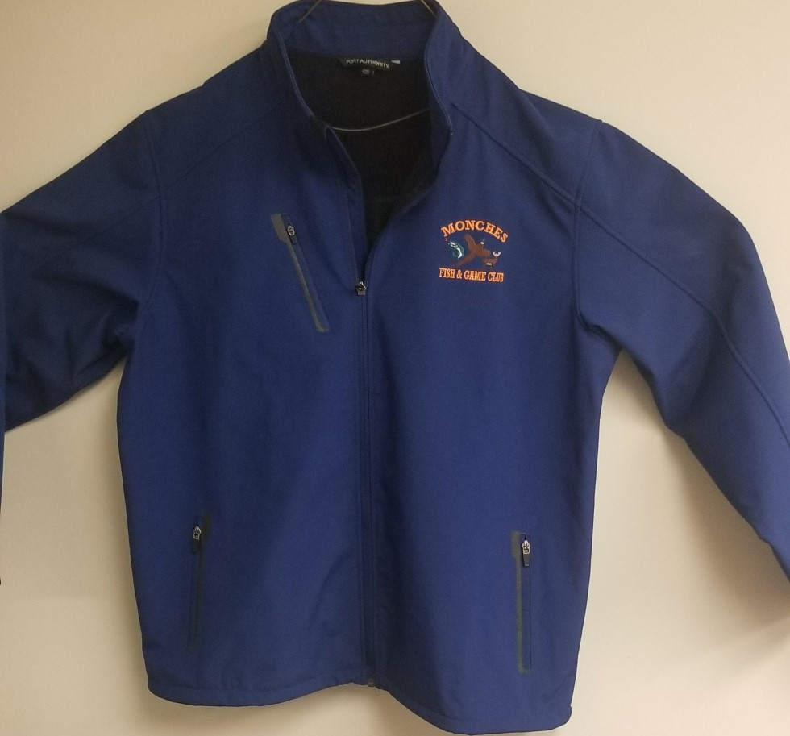

Item # J324
Material: 100% Polyester. ( Welded ) Softshell Jacket with Chest & Side Pockets
Water & Wind Resistant.
Color Options: Black / Battleship Gray / Navy / Estate Blue /
Letter Color: Black / Red / White / Orange
Price: SM – XL $56.99
Price: 2XL – 4XL $62.99

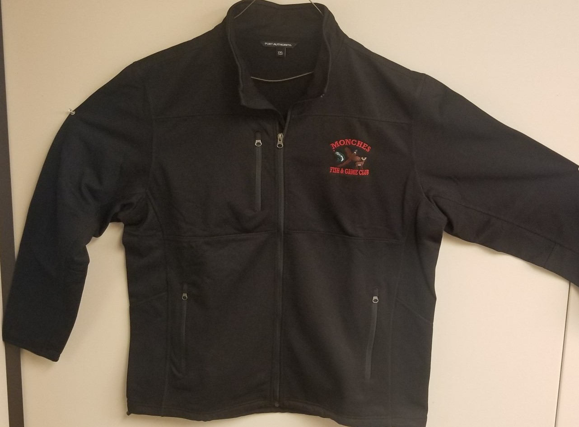

Item # F222 Port Authority – ( Pique ) Fleece Jacket
Material: 14.0 Oz 100% Polyester with Chest & Side Pockets
Color Options: ( Black / Navy / Charcoal )
Letter Color Options: Black / Red / White / Orange
Price: SM – XL $52.99
Price: 2XL – 4XL $57.99

